**Chapter 4**

**Applications of Derivatives**

**4.7 Applied Optimization Problems**

**Section Exercises**

**For the following exercises, answer by proof, counterexample, or explanation.**

311. When you find the maximum for an optimization problem, why do you need to check the sign of the derivative around the critical points?

Answer: The critical points can be the minima, maxima, or neither.

313. *True or False*. For every continuous nonlinear function, you can find the value  that maximizes the function.

Answer: False; has a minimum only

**For the following exercises, set up and evaluate each optimization problem.**

315. To carry a suitcase on an airplane, the length  height of the box must be less than or equal to  Assuming the height is fixed, show that the maximum volume is  What height allows you to have the largest volume?

Answer: in.

317. Find the positive integer that minimizes the sum of the number and its reciprocal.

Answer: 

**For the following exercises, consider the construction of a pen to enclose an area.**

319. You have  of fencing to construct a rectangular pen for cattle. What are the dimensions of the pen that maximize the area?

Answer:

321. You need to construct a fence around an area of  What are the dimensions of the rectangular pen to minimize the amount of material needed?

Answer: 

323. **[T]** You are moving into a new apartment and notice there is a corner where the hallway narrows from. What is the length of the longest item that can be carried horizontally around the corner?

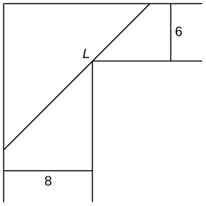

Answer:

325. In the previous problem, assume the patient was nervous during the third measurement, so we only weight that value half as much as the others. What is the value that minimizes

Answer: 

**For the following problems, consider a lifeguard at a circular pool with diameter  He must reach someone who is drowning on the exact opposite side of the pool, at position  The lifeguard swims with a speed  and runs around the pool at speed**

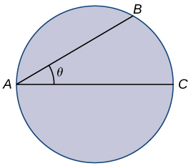

327. Find a function that measures the total amount of time it takes to reach the drowning person as a function of the swim angle, 

Answer:

329. A truck uses gas as where represents the speed of the truck and  represents the gallons of fuel per mile. At what speed is fuel consumption minimized?

Answer:

**For the following exercises, consider a limousine that gets at speed the chauffeur costs , and gas is **

331. Find the cheapest driving speed.

Answer: approximately

**For the following exercises, consider a pizzeria that sell pizzas for a revenue ofand costs where represents the number of pizzas.**

333. Assume that and How many pizzas sold maximizes the profit?

Answer: 

**For the following exercises, consider a wire  long cut into two pieces. One piece forms a circle with radius  and the other forms a square of side **

335. Choose  to maximize the sum of their areas.

Answer: 

**For the following exercises, consider two nonnegative numbers  and  such that  Maximize and minimize the quantities.**

337. 

Answer: Maximal: minimal: and

339. 

Answer: Maximal:  minimal: none

**For the following exercises, draw the given optimization problem and solve.**

341. Find the volume of the largest right circular cylinder that fits in a sphere of radius 

Answer:

343. Find the area of the largest rectangle that fits into the triangle with sides  and 

Answer: 

345. Find the dimensions of the closed cylinder volume  that has the least amount of surface area.

Answer:

**For the following exercises, consider the points on the given graphs. Use a calculator to graph the functions.**

347. **[T]** Where is the line closest to the origin?

Answer:

349. **[T]** Where is the parabola  closest to point?

Answer: 

**For the following exercises, set up, but do not evaluate, each optimization problem.**

351. A window is composed of a semicircle placed on top of a rectangle. If you have  of window-framing materials for the outer frame, what is the maximum size of the window you can create? Use to represent the radius of the semicircle.

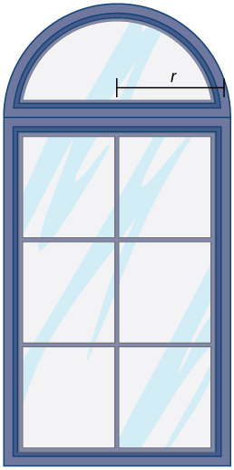

Answer:

353. You are constructing a box for your cat to sleep in. The plush material for the square bottom of the box costs  and the material for the sides costs  You need a box with volume  Find the dimensions of the box that minimize cost. Use  to represent the length of the side of the box.

Answer:

355. You are the manager of an apartment complex with  units. When you set rent at  all apartments are rented. As you increase rent by  one fewer apartment is rented. Maintenance costs run  for each occupied unit. What is the rent that maximizes the total amount of profit?

Answer:

This file is copyright 2016, Rice University. All Rights Reserved.